Generate a Report in MOSAIQ

1. Go to File > Print Reports.

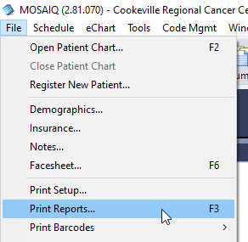

1. Navigate to and highlight the data you want in the report. Click Run.

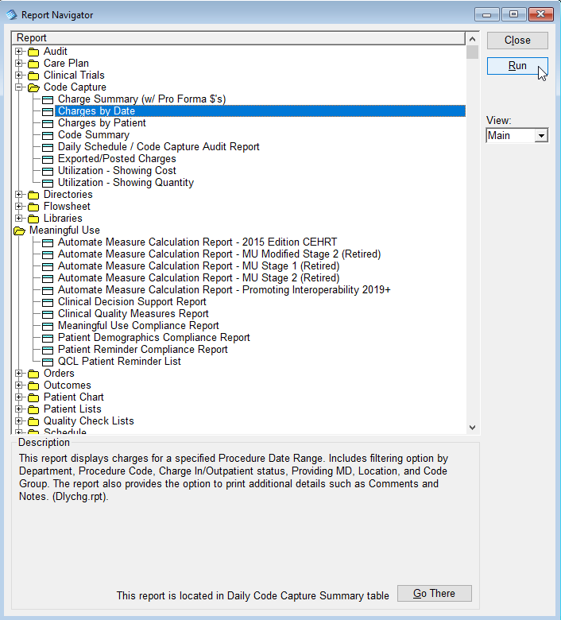

1. Enter the appropriate settings. Click OK.

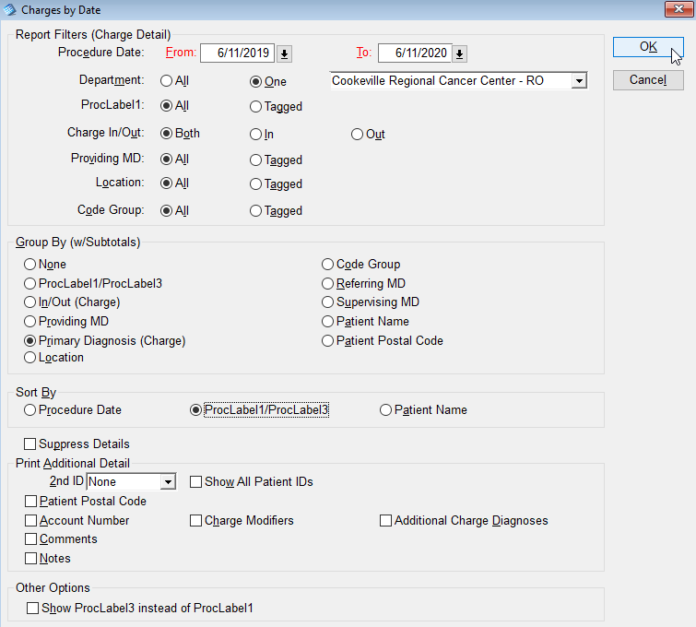

1. Choose the location to which you want the report to print. Click OK.

